**Title:** Integer Linear programming outperforms simulated annealing for solving conservation planning problems

**Authors:** Richard Schustera,b,*, Jeffrey O. Hansonc, Matt Strimas-Mackeyd, Joseph R. Bennetta

a Department of Biology, 1125 Colonel By Drive, Carleton University, Ottawa ON, K1S 5B6 Canada.

b Ecosystem Science and Management Program, 3333 University Way, University of Northern British Columbia, Prince George BC, V2N 4Z9 Canada.

c School of Biological Sciences, The University of Queensland, Brisbane, QLD 4072, Australia

d Cornell Lab of Ornithology, Cornell University, Ithaca, NY 14850 USA.

**\*** Corresponding author:Richard Schuster, Department of Biology, 1125 Colonel By Drive, Carleton University, Ottawa ON, K1S 5B6 Canada. 250-635-2321. richard.schuster@glel.carleton.ca

**Keywords**: Marxan, Integer Linear Programming, Optimization, Prioritization, Conservation Planning, prioritizr

**Abstract**

There are two main approaches to solving systematic conservation planning problems, Simulated Annealing (SA) and Integer linear programming (ILP). We compare the cost-effectiveness and processing times of both approaches. Using ILP algorithms resulted in cost savings ranging from 12 to 30% compared to SA. The best ILP solver we used was on average 1071 times faster than the SA algorithm tested. One practical advantage of using ILP over SA is that the analysis does not require calibration, saving even more time. Given the performance of ILP solvers, they can be used to generate conservation plans in real-time duringstakeholder meetings, making the conservation planning process more interactive. Given recent advances in computing power and ILP algorithms, we hope that ILP solvers will have their place in systematic conservation planning.

**Introduction**

Systematic conservation planning (SCP) is a rigorous, repeatable, and structured approach for designing new protected areas that efficiently meet conservation objectives (Margules and Pressey 2000). Historically, spatial conservation decision-making often evaluated parcels opportunistically as they became available for purchase, donation, or under threat (Pressey et al. 1993, Pressey and Bottrill 2008). Although purchasing such areas may improve the status quo, such decisions may not substantially enhance the long-term persistence of species or communities or be cost-effective (Joppa and Pfaff 2009, Venter et al. 2014). SCP, on the other hand, involves framing conservation planning problems as optimization problems, with clearly defined objectives (e.g. minimize acquisition cost) and constraints (e.g. targets). These optimization problems are then solved to obtain candidate reserve designs (termed prioritizations), which are used to guide protected area acquisitions and land policy (Schwartz et al. 2018). Due to the systematic, evidence-based nature of these tools, they can help contribute to a transparent, inclusive, and more defensible decision-making process (ref needed).

Today, Marxan is the most widely used SCP software, being used in 184 countries to design marine and terrestrial reserve systems (Ball et al. 2009). Although Marxan supports several algorithms for solving conservation planning problems, most conservation planning exercises use its implementation of the simulated annealing (SA), an iterative, stochastic metaheuristic for approximating global optima of complex functions with many local optima. By conducting thousands of individual runs, each with millions of iterations, Marxan aims to generate solutions that are near-optimal. However, this approach provides no guarantee on solution quality. In particular, solutions may be highly suboptimal and conservation scientists and practitioners have no way of knowing how far from optimality generated solutions are.

ear-optimal solutions to optimization problems in some circumstances.

In a recent simulation study, Beyer et al. (2016) found that Marxan with simulated annealing can deliver solutions that are orders of maginitude below optimality. They compared Marxan to integer linear programming (ILP) (Dantzig 2016), which minimizes or maximizes an objective function (a mathematical equation describing the relationship between actions and outcomes) subject to a set of constraints and conditional on the decision variables (the variables corresponding to the selection of actions to implement) being integers (Beyer et al. 2016). Unlike heuristic methods such as SA, prioritization using ILP will find the exact optimal solution or can be instructed to return solutions within a defined distance from optimality. Some have argued that ILP approaches are well-suited for solving conservation planning problems (Underhill 1994, Rodrigues and Gaston 2002), but only recent advances in computational capacity and algorithms have made it possible to solve the Marxan-like SCP problems with ILP for large problems (Beyer et al. 2016). Building on Beyer et al. (Beyer et al. 2016), we created a software package for the R statistical software called prioritizr, that can solve Marxan type problems, among others, using ILP (Hanson et al. 2019). However, the performance of Marxan with real-world datasets is unknown.

Here we compare integer linear programming with simulated annealing (i.e. Marxan) for solving systematic conservation planning problems using real-world data from Western North America. We found that ILP produced higher quality solutions and that solutions were generated more quickly. Our results suggest that blah blah blah.

**Methods**

*Study area*

We focused on a 27,250 km2 portion of the Georgia Basin, Puget Trough and Willamette Valley of the Pacific Northwest region spanning the US and Canada (Fig. 1), corresponding to the climate envelope indicative of the Coastal Douglas-fir (CDF) Biogeoclimatic zone in southwestern British Columbia (Meidinger and Pojar 1991). Land cover in the region is diverse, with approximately 57% of the land in forest, 8% as savanna or grassland, 5% in cropland, and 10% being urban or built.

*Biodiversity data.*

We used species distribution models for 72 bird species as our conservation features (Supplementary Table 1).The distribution models were based on data from eBird, a citizen-science effort that has produced the largest and most rapidly growing biodiversity database in the world (Hochachka et al. 2012, Sullivan et al. 2014). From the 2013 eBird Reference Dataset (<http://ebird.org/ebird/data/download>) we used a total of 12,081 checklists in our study area, then filtered these checklists to retain only those <1.5 hours in duration, <5 km travelled, and with a maximum of 10 visits to a given location (unpublished R code; Hochachka, pers. com.). Sampling locations <100 m apart were collapsed to one location, yielding 5,470 checklists from 2,160 locations, visited from 1-10 times and 2.53 times on average. The R package unmarked (version 0.9-9; Fiske and Chandler 2011) provided the framework for all species distribution models, which necessarily include two parts: occupancy and detection (Mackenzie et al. 2002). For further details on biodiversity data see Rodewald et al. (XXXX).

*Cadastral layer and land cost*.

We incorporated spatial heterogeneity in land cost (Ando et al. 1998, Polasky et al. 2001, Ferraro 2003, Naidoo et al. 2006) in our plan by using cadastral data and 2012 land value assessments from the Integrated Cadastral Information Society of BC, resulting in 193,623 polygons for BC (Schuster et al. 2014). Cadastral data, including tax assessment land values from Washington State came from the University of Washington’s Washington State Parcel Database (<https://depts.washington.edu/wagis/projects/parcels/>; Version: StatewideParcels_v2012n_e9.2_r1.3; Date accessed: 2015/04/30), as well as San Juan County Parcel Data with separate signed user agreement. The combined cadastral layer included 1.92 million polygons. Cadastral data, including tax assessment land values from Oregon State had to be sourced from individual counties, which included Benton, Clackamas, Columbia, Douglas, Lane, Linn, Marion, Multnomah, Polk, Washington and Yamhill. The combined cadastral layer for Oregon included 605,425 polygons.

*Spatial prioritization approach*

We compared ILP and SA for solving the Marxan spatial prioritization problem. In this formulation, the landscape is divided into a set of discrete planning units. Each planning unit is assigned a socioeconomic cost (here we use the assessed land value) and a conservation value for a set of features that we wish to protect (here the occupancy probability for a set of species). Finally, we define representation targets for each species as the amount of habitat we hope to protect for each species. The ultimate goal of this prioritization problem is to optimize the trade-off between conservation benefit and socioeconomic cost (McIntosh et al. 2017). Achieving this goal involves finding the set of planning units that meets the conservation targets for the minimum possible cost.

Marxan formulation

Integer linear programming is the subset of optimization algorithms used here to solve reserve design problems. The general form of an ILP problem can be expressed in matrix notation as:

$$MinimizecxsubjectAx≥b$$

Where x is a vector of decision variables (in our case, whether to prioritize an individual planning unit), c and b are vectors of known coefficients, and A is the constraint matrix. In the minimum set cover problem, c is a vector of costs for each planning unit, b a vector of targets for each conservation feature, the relational operator would be ≥ for all features, and A is the representation matrix with Aij=rij, the representation level of feature i in planning unit j. We set an objective to find the solution that fulfills all the targets and constraints for the least cost (Beyer et al. 2016).

*ILP solvers (commercial vs open source)*

A variety of ILP solvers currently exist, and both commercial and open source solvers are available. All solvers ideally yield optimal solutions to ILP problems, but there are substantial differences in performance and in the size of problems that can be solved (citation neeeded). For the purposes of performance testing we opted for one of the best commercial solvers currently on the market, Gurobi (Gurobi Optimization Inc. 2017). In a recent benchmark study, Gurobi outperformed other solver packages for more complex formulations and a practical use-case (Luppold et al. 2018). Gurobi provides a free academic license to researchers, but is otherwise costly for non academic institutions and individuals. To investigate solver performance of packages that are freely available to everyone, we also tested the open source solver SYMPHONY (Ted Ralphs et al. 2019). Both Gurobi and SYMPHONY can be used from R. For Gurobi we used the R package provided with the software (gurobi version 8.1-0) and for SYMPHONY the Rsymphony package (version 0.1-28; Harter et al. 2017).

*Scenarios investigated*

We investigated a range of scenarios that were computationally feasible for this study. For both Marxan and prioritzr we created the following range of scenarios: i) vary conservation targets between 10 and 90% in 10% increments (9 variations), using ii) 10 – 72 species/features (5 variations) as targets, and iii) with spatial extents of 9,282, 37,128, and 148,510 planning units (3 variations), resulting in a total of 135 scenarios created. For Marxan, we also varied two additional parameters, i) the number of iterations ranged from 104 to 108 (5 variations) and ii) species penalty factors (SPF) of 1, 5, 25, and 125 were explored (4 variations) for a total of 2,700 scenarios investigated in Marxan. As the processing time for the most complex problem in Marxan (90% target, 72 features, 148,510 planning units, 108 iterations) was >8 hours, we restricted the full range of scenarios to those mentioned above. However, to explore the effect of larger numbers of planning units within computational limitations, we created an additional 9 scenarios (targets ranging from 10 – 90 %, with 72 features, 108 iterations and SPF = 5) with 594,040 planning units. This number of planning units is well within the range of previous studies using Marxan (refs – Karissa, Australia Marine Marxan?), although using more than 50,000 planning units with SA is discouraged without extensive parameter calibration, as near optimal solutions will be hard to find for problems of that size (Ardron et al. 2010).

**Results**

ILP algorithms (Gurobi, Symphony) outperformed SA (Marxan) in terms of their ability to find optimal solutions across all scenarios. Through finding solutions closer to optimality, using ILP resulted in cost savings ranging from 12 to 30%. At the 30% protection target ILP solvers resulted in solutions that were $144M cheaper than SA (Figure 1). With these savings an additional 3,039 ha could be protected (53,934 ha vs 50,895 ha) using an ILP approach by raising the representation targets until the cost of the resulting solution matched that of the Marxan solution.

The best processing times were achieved using the prioritizr package and the commercial solver Gurobi, followed by prioritizr and the open source solver Symphony, and lastly Marxan (Figure 2). Gurobi was as fast or faster across all scenarios investigated, Symphony took between 0 and 113 times longer than Gurobi (mean = 18.4 times), and Marxan took between 0 and 28710 times longer than Gurobi (mean = 1071 times).

**Discussion**

We found that ILP algorithms outperformed SA both in terms of cost-effectiveness and processing times. There have been calls for using ILP in solving conservation planning problems in the past (Underhill 1994, Rodrigues and Gaston 2002), but we are only now getting to a point where making this switch is computationally feasible. With the drawback of failing to solve large problems diminishing, or really disappearing, the second drawback identified of presenting a single best solution being not that useful for practical and political reasons is all that remains (Ball et al. 2009). One could argue that this would not represent an insurmountable issue and we think the benefits of finding the optimal solution to a conservation planning problem will likely outweigh that drawback.

One practical advantage of using ILP over SA is that the analysis does not require calibration. A crucial task in every Marxan/SA prioritization is the calibration of parameter for the analysis (Ardron et al. 2010). This task can be very time consuming, especially for larger problems. At the very least species penalty factor (SPF), number of SA iterations and number of restarts should be calibrated. Ideally parameters should be explored over the entire parameter space, which would mean that if we wanted to explore three values for each parameter, we would end up with 27 (3 * 3 *3) scenarios to explore. With the most complex problem investigated here this would take in the order of 5 days just to calibrate Marxan runs, which we have done before finalizing parameters and presenting results. None of this calibration time is necessary using ILP. This explains the difference in number of scenarios investigated between ILP (135) and SA (2700) as shown in Table 1. An added benefit is that the somewhat subjective process of setting values for these three parameters can be eliminated using ILP as well.

With the recommendation of a maximum number of 50,000 planning units for a Marxan analysis (Ardron et al. 2010), current trends for larger problem sizes can’t be accommodated using SA approaches. On the other hand, ILP/prioritizr can handle problem sizes of >1M planning units (Schuster et al. 2018)**.**

Finally, we would argue that another strength of ILP solvers, especially Gurobi, is that they can be used to quickly explore and compare different conservation prioritization scenarios in real-time. Especially when the ILP solvers are made accessibly in a way that interacting with them is easy and allows for visualization and exploration. We have created a number of interactive web apps using the R package shiny (Chang et al. 2018) that interface with the prioritizr package, one of which has successfully been used in stakeholder meetings to help inform the conservation strategy for a regional conservation partnership (CDFCP 2015)

Given the widespread use of Marxan/SA in conservation planning, it might be a hard sell for many Marxan users to switch to a new approach. Given this fact, we hope that future versions of Marxan will include the option to use ILP solvers in addition to SA. This way the current user base would not have to switch to a new product, but Marxan could take advantage of ILP solvers to improve both cost-effectiveness and speed. For the time being, we hope that the merits of ILP solvers can be pointed out of systematic conservation planners via studies like this one, to allow for the option of using either SA or ILP where appropriate.

**Conclusion**

ILP algorithms outperform SA as used in Marxan substantially, both in terms of solution cost, as well as in terms of time required to find near optimal or optimal solutions. Using an ILP algorithm, as implemented in the R package prioritizr, has the added benefit that users don’t need to worry or set parameters such as species penalty factors or number of iterations anymore, which significantly reduces the time a user spends on finding suitable values for these parameters. With the capabilities of prioritizr, including everything Marxan can do and more, we highly recommend users adopting this modified approach to solving systematic conservation planning problems.

**Acknowledgements**

RS is supported by a Liber Ero Fellowship and Environment and Climate Change Canada (ECCC), JOH by XXX , MSM by endowments at the Cornell Lab of Ornithology, and JRB by Natural Sciences and Engineering Research Council of Canada and ECCC.

**References**

Ando, A., J. Camm, S. Polasky, and A. Solow. 1998. Species Distributions, Land Values, and Efficient Conservation. Science 279:2126–2128.

Ardron, J. A., H. P. Possingham, and C. J. Klein, editors. 2010. Marxan Good Practices Handbook, Version 2. Pacific Marine Analysis and Research Association, Victoria, BC, Canada.

Ball, I. R. R., H. P. P. Possingham, and M. E. E. Watts. 2009. Marxan and relatives: Software for spatial conservation prioritisation. Pages 185–195 *in* A. Moilanen, K. Wilson, and H. P. Possingham, editors. Spatial conservation prioritisation: Quantitative methods and computational tools. Oxford University Press, Oxford.

Beyer, H. L., Y. Dujardin, M. E. Watts, and H. P. Possingham. 2016. Solving conservation planning problems with integer linear programming. Ecological Modelling 328:14–22.

CDFCP. 2015. Conservation Strategy. Coastal Douglas Fir & Associated Ecosystems Conservation Partnership.

Chang, W., J. Cheng, J. J. Allaire, Y. Xie, J. McPherson, RStudio, jQuery F. (jQuery library and jQuery U. library), jQuery contributors (jQuery library; authors listed in inst/www/shared/jquery-AUTHORS.txt), jQuery U. contributors (jQuery U. library; authors listed in inst/www/shared/jqueryui/AUTHORS.txt), M. O. (Bootstrap library), J. T. (Bootstrap library), B. contributors (Bootstrap library), Twitter, I. (Bootstrap library), A. F. (html5shiv library), S. J. (Respond js library), S. P. (Bootstrap-datepicker library), A. R. (Bootstrap-datepicker library), D. G. (Font-A. font), B. R. (selectize js library), K. M. K. (es5-shim library), es5-shim contributors (es5-shim library), D. I. (ion rangeSlider library), S. S. (Javascript strftime library), S. L. (DataTables library), J. F. (showdown js library), J. G. (showdown js library), I. S. (highlight js library), and R. C. T. (tar implementation from R). 2018. shiny: Web Application Framework for R.

Dantzig, G. 2016. Linear Programming and Extensions. Princeton University Press.

Ferraro, P. J. 2003. Assigning priority to environmental policy interventions in a heterogeneous world. Journal of Policy Analysis and Management 22:27–43.

Fiske, I. J., and R. B. Chandler. 2011. unmarked : An R Package for Fitting Hierarchical Models of Wildlife Occurrence and Abundance. Journal Of Statistical Software 43:128–129.

Gurobi Optimization Inc. 2017. Gurobi Optimizer Reference Manual, Version 7.5.1.

Hanson, J., R. Schuster, N. Morrell, M. Strimas-Mackey, M. E. Watts, P. Arcese, J. R. Bennett, and H. P. Possingham. 2019. prioritizr: Systematic Conservation Prioritization in R, Version 4.0.2.

Harter, R., K. Hornik, S. Theussl, C. Szymanski, and F. Schwendinger. 2017. Rsymphony: SYMPHONY in R.

Hochachka, W. M., D. Fink, R. A. Hutchinson, D. Sheldon, W.-K. Wong, and S. Kelling. 2012. Data-intensive science applied to broad-scale citizen science. Trends in ecology & evolution 27:130–137.

Joppa, L. N., and A. Pfaff. 2009. High and far: biases in the location of protected areas. PloS one 4:e8273.

Kirkpatrick, S., C. D. Gelatt, and M. P. Vecchi. 1983. Optimization by Simulated Annealing. Science 220:671–680.

Luppold, A., D. Oehlert, and H. Falk. 2018. Evaluating the performance of solvers for integer-linear programming.

Mackenzie, D. I., J. D. Nichols, G. B. Lachman, S. J. Droege, J. A. Royle, and C. A. Langtimm. 2002. Estimating site occupancy rates when detection probabilities are less than one. Ecology 83:2248–2255.

Margules, C. R., and R. L. Pressey. 2000. Systematic conservation planning. Nature 405:243–53.

McIntosh, E. J., R. L. Pressey, S. Lloyd, R. Smith, and R. Grenyer. 2017. The Impact of Systematic Conservation Planning. Annual Review of Environment and Resources 42:annurev-environ-102016-060902.

Meidinger, D., and J. Pojar. 1991. Ecosystems of British Columbia. British Columbia Ministry of Forests, Victoria, BC.

Naidoo, R., A. Balmford, P. J. Ferraro, S. Polasky, T. H. Ricketts, and M. Rouget. 2006. Integrating economic costs into conservation planning. Trends in ecology & evolution 21:681–7.

Polasky, S., J. D. Camm, and B. Garber-Yonts. 2001. Selecting Biological Reserves Cost-Effectively: An Application to Terrestrial Vertebrate Conservation in Oregon. Land Economics 77:68–78.

Pressey, R., C. Humphries, C. Margules, R. Vane-Wright, and P. Williams. 1993. Beyond opportunism: key principles for systematic reserve selection. Trends in ecology & evolution 8:124–128.

Pressey, R. L., and M. C. Bottrill. 2008. Opportunism, Threats, and the Evolution of Systematic Conservation Planning. Conservation Biology 22:1340–1345.

Rodrigues, A. S. L., and K. J. Gaston. 2002. Optimisation in reserve selection procedures—why not? Biological Conservation 107:123–129.

Schuster, R., T. G. Martin, and P. Arcese. 2014. Bird Community Conservation and Carbon Offsets in Western North America. Plos One.

Schuster, R., S. Wilson, A. Rodewald, P. Arcese, D. Fink, T. Auer, and J. Bennett. 2018. Optimizing conservation of migratory species over their full annual cycle in the Western Hemisphere. bioRxiv.

Schwartz, M. W., C. N. Cook, R. L. Pressey, A. S. Pullin, M. C. Runge, N. Salafsky, W. J. Sutherland, and M. A. Williamson. 2018. Decision Support Frameworks and Tools for Conservation. Conservation Letters 11:e12385.

Sullivan, B. L., J. L. Aycrigg, J. H. Barry, R. E. Bonney, N. Bruns, C. B. Cooper, T. Damoulas, A. A. Dhondt, T. Dietterich, A. Farnsworth, and others. 2014. The eBird enterprise: an integrated approach to development and application of citizen science. Biological Conservation 169:31–40.

Ted Ralphs, Ashutosh Mahajan, Stefan Vigerske, mgalati13, LouHafer, jpfasano, Aykut Bulut, and anhhz. 2019. coin-or/SYMPHONY: Version 5.6.17. Zenodo.

Underhill, L. G. 1994. Optimal and suboptimal reserve selection algorithms. Biological Conservation 70:85–87.

Venter, O., R. A. Fuller, D. B. Segan, J. Carwardine, T. Brooks, S. H. M. Butchart, M. D. Marco, T. Iwamura, L. Joseph, D. O’Grady, H. P. Possingham, C. Rondinini, R. J. Smith, M. Venter, and J. E. M. Watson. 2014. Targeting Global Protected Area Expansion for Imperiled Biodiversity. PLOS Biology 12:e1001891.

**Table 1.**

|  |  |  |  |
| --- | --- | --- | --- |
| **Paremeter** | **Value range** | **n** | **Scenarios** |
| targets | 10 - 90% | 9 |  |
| # features | 10, 26, 41, 56, 72 | 5 |  |
| # planning units | 9,282, 37,128, 148,510 | 3 | 135 (ILP) |
| Marxan iterations | 104, 105, 106, 107, 108 | 5 |  |
| Marxan SPF | 1, 5, 25, 125 | 4 | 2,700 (Marxan) |

**Figure 1.**

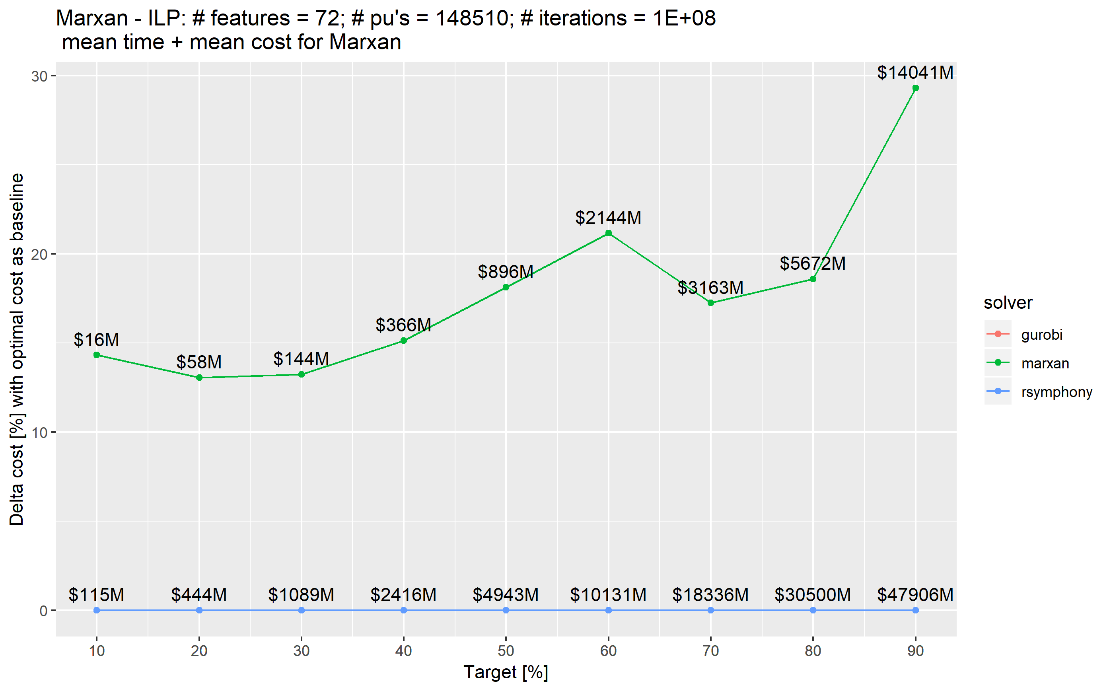

**Figure 2.**

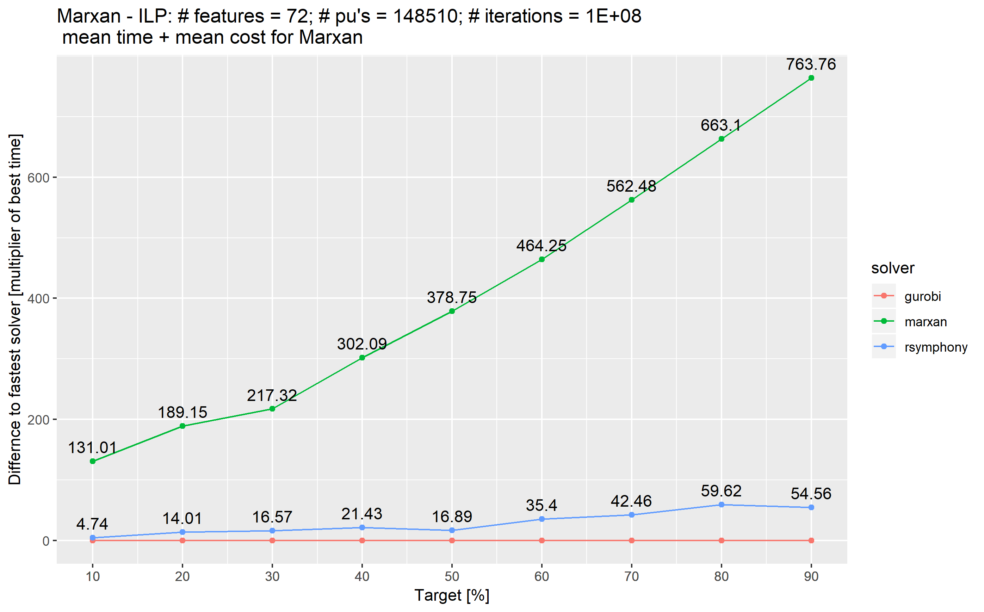

**Supplementary Table 1.**

|  |  |  |
| --- | --- | --- |
| Species Code | Common Name | Scientific Name |
| amegfi | American Goldfinch | Spinus tristis |
| amekes | American Kestrel | Falco sparverius |
| amerob | American Robin | Turdus migratorius |
| annhum | Anna's Hummingbird | Calypte anna |
| baleag | Bald Eagle | Haliaeetus leucocephalus |
| barswa | Barn Swallow | Hirundo rustica |
| brdowl | Barred Owl | Strix varia |
| belkin1 | Belted Kingfisher | Megaceryle alcyon |
| bewwre | Bewick's Wren | Thryomanes bewickii |
| bnhcow | Brown-headed Cowbird | Molothrus ater |
| bkhgro | Black-headed Grosbeak | Pheucticus melanocephalus |
| brebla | Brewer's Blackbird | Euphagus cyanocephalus |
| brncre | Brown Creeper | Certhia americana |
| batpig1 | Band-tailed Pigeon | Patagioenas fasciata |
| bushti | Bushtit | Psaltriparus minimus |
| cangoo | Canada Goose | Branta canadensis |
| chbchi | Chestnut-backed Chickadee | Poecile rufescens |
| cedwax | Cedar Waxwing | Bombycilla cedrorum |
| chispa | Chipping Sparrow | Spizella passerina |
| coohaw | Cooper's Hawk | Accipiter cooperii |
| comrav | Common Raven | Corvus corax |
| amecro | American Crow | Corvus brachyrhynchos |
| dowwoo | Downy Woodpecker | Dryobates pubescens |
| eucdov | Eurasian Collared-Dove | Streptopelia decaocto |
| eursta | European Starling | Sturnus vulgaris |
| evegro | Evening Grosbeak | Coccothraustes vespertinus |
| norfli | Northern Flicker | Colaptes auratus |
| foxspa | Fox Sparrow | Passerella iliaca |
| gockin | Golden-crowned Kinglet | Regulus satrapa |
| haiwoo | Hairy Woodpecker | Dryobates villosus |
| houfin | House Finch | Haemorhous mexicanus |
| houspa | House Sparrow | Passer domesticus |
| houwre | House Wren | Troglodytes aedon |
| hutvir | Hutton's Vireo | Vireo huttoni |
| macwar | MacGillivray's Warbler | Geothlypis tolmiei |
| moudov | Mourning Dove | Zenaida macroura |
| norhar1 | Hen Harrier | Circus cyaneus |
| orcwar | Orange-crowned Warbler | Oreothlypis celata |
| olsfly | Olive-sided Flycatcher | Contopus cooperi |
| osprey | Osprey | Pandion haliaetus |
| pacwre1 | Pacific Wren | Troglodytes pacificus |
| pinsis | Pine Siskin | Spinus pinus |
| pilwoo | Pileated Woodpecker | Dryocopus pileatus |
| pasfly | Pacific-slope Flycatcher | Empidonax difficilis |
| purfin | Purple Finch | Haemorhous purpureus |
| purmar | Purple Martin | Progne subis |
| rebnut | Red-breasted Nuthatch | Sitta canadensis |
| rebsap | Red-breasted Sapsucker | Sphyrapicus ruber |
| redcro | Red Crossbill | Loxia curvirostra |
| rocpig | Rock Pigeon | Columba livia |
| rethaw | Red-tailed Hawk | Buteo jamaicensis |
| rufhum | Rufous Hummingbird | Selasphorus rufus |
| rewbla | Red-winged Blackbird | Agelaius phoeniceus |
| savspa | Savannah Sparrow | Passerculus sandwichensis |
| sora | Sora | Porzana carolina |
| sonspa | Song Sparrow | Melospiza melodia |
| spotow | Spotted Towhee | Pipilo maculatus |
| stejay | Steller's Jay | Cyanocitta stelleri |
| swathr | Swainson's Thrush | Catharus ustulatus |
| towwar | Townsend's Warbler | Setophaga townsendi |
| treswa | Tree Swallow | Tachycineta bicolor |
| daejun | Dark-eyed Junco | Junco hyemalis |
| yerwar | Yellow-rumped Warbler | Setophaga coronata |
| varthr | Varied Thrush | Ixoreus naevius |
| vigswa | Violet-green Swallow | Tachycineta thalassina |
| warvir | Warbling Vireo | Vireo gilvus |
| whcspa | White-crowned Sparrow | Zonotrichia leucophrys |
| westan | Western Tanager | Piranga ludoviciana |
| wilsni1 | Wilson's Snipe | Gallinago delicata |
| wlswar | Wilson's Warbler | Cardellina pusilla |
| wooduc | Wood Duck | Aix sponsa |
| yelwar | Yellow Warbler | Setophaga petechia |